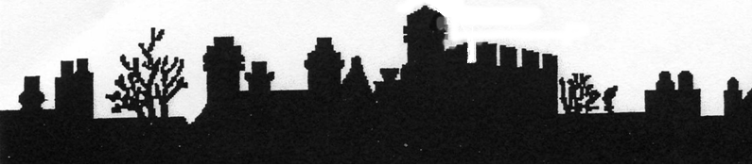

MEMBERSHIP APPLICATION FORM

The membership runs from 1st April to 31st March

[Subscriptions: UK - £10.00 - cheques made payable to ‘Oundle Historical Society]

Please PRINT your details-

Title (Mt/Mrs/Miss/Ms) ……………………………………………INITIALS………………………

SURNAME ………………………………………………………………………………………………

ADDRESS………………………………………………………………………………………………..

……………………………………………………………………………………………………………

……………………………………………………………………………………………………………

……………………………………………………………………………………………………………

POST CODE / ZIP …………………………………… TELEPHONE………………………………

DATE ……………………………………… EMAIL …………………………………………………..

I AGREE TO THE HOLDING OF MY RECORD ON A COMPTER FILE (This will only be used for communication to you from the Society) Delete the statement if permission is not granted.

DATE ………………………………….SIGNATURE…………………………………………………

Completed forms should be sent to:

The Membership Secretary,
Oundle Historical Society,
c/o Oundle Museum,
The Courthouse,
Mill Road,
Oundle.
PE8 4BW.

Prior to the AGM members receive a reminder that membership renewal is due at that meeting, when they will receive their Membership/Programme Card for the coming year. If they are unable to attend the card will be forward to them on receipt of the subscription. However members who pay their annual subscription by Standing Order will receive their Membership/Programme Card before the AGM.

A Standing Order form is included below.

STANDING ORDER FORM

Please send this form:
To the manager…………………………………………………………………………………………...
(Name and address of your bank)

……………………………………………………………………………………………………………

……………………………………………………………………………………………………………

……………………………………………………………………………………………………………

Please Pay Oundle Historical Society
Sort code: 54 21 22 Account No: 31126790

Oundle Historical Society reference:
(Please insert your initials and surname) ………………………………………………………………...

The sum of £……….. Annually from my/our account No : …………………. Sort code:…………….

Starting on ………………. and then on 30th March annually until further notice.

Name …………………………………… Signature …………………………. Date …………….

Address: ……………………………………………………………………………………………………………

……………………………………………………………………………………………………………

……………………………………………………………………………………………………………

